1. Created *EventTrigger.exe*, console app to trigger events continuously with following format:

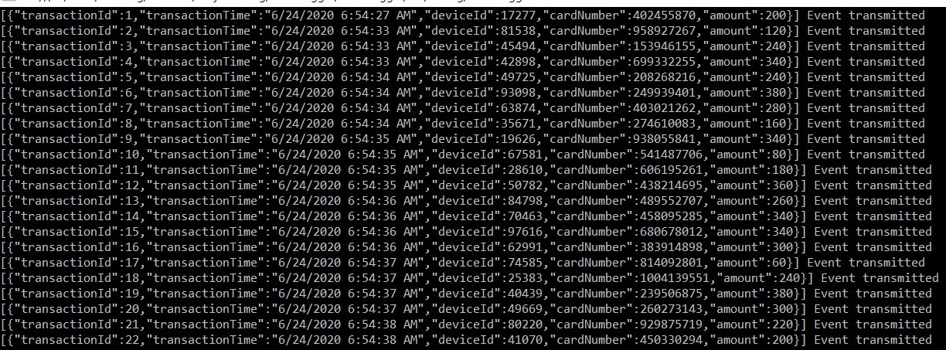



1. These events are captured in event hub created on Azure

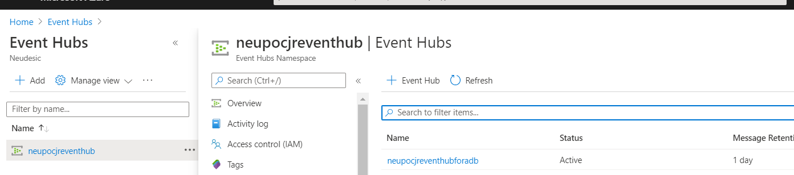

1. Once these events are captured in *neupocjreventhubforadb*, created azure notebook to fetch these events from eventhub.

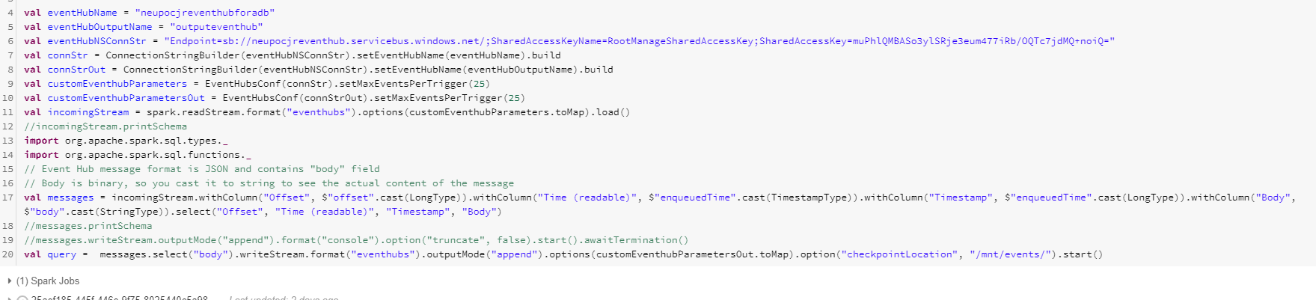

1. After events are captured in azure databricks, these events are parsed and only ‘*body’* of the event is transferred to another eventhub(*outputeventhub*) created to fetch output and show in power bi report

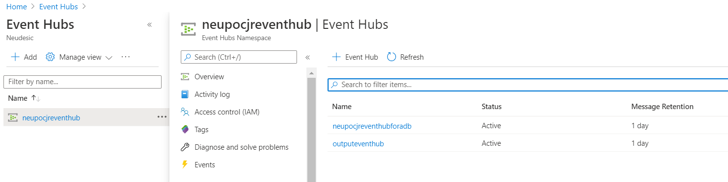



1. Created stream analytics job which will take input as *outputeventhub* and output as Power BI report

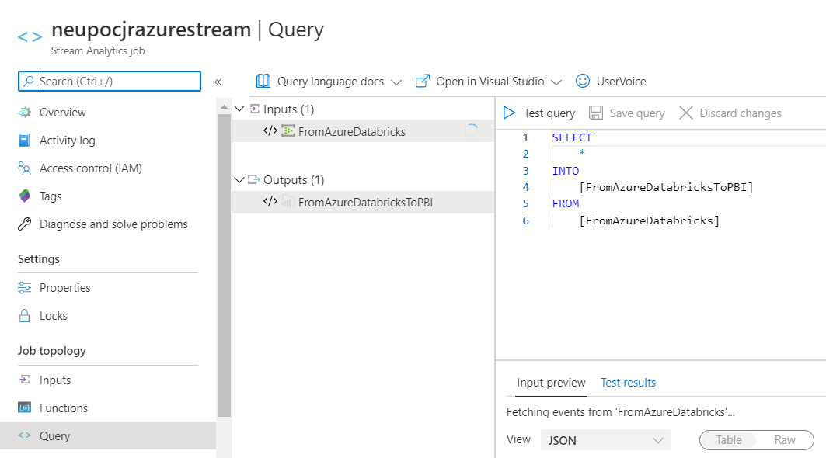

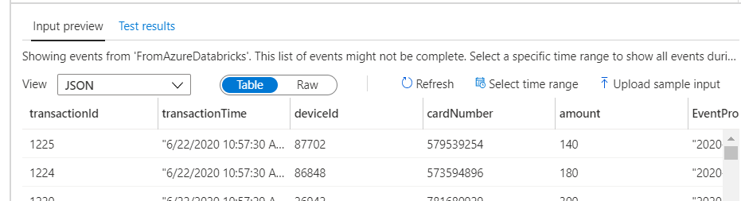

1. Dataset is created for Power BI report:

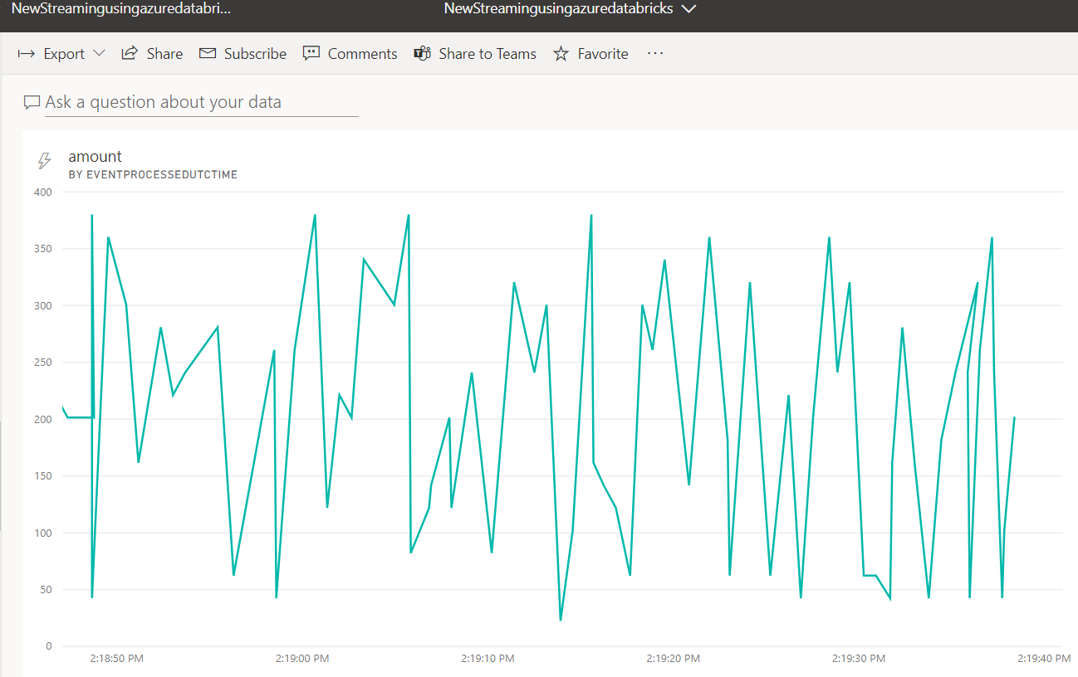

Video link: <https://web.microsoftstream.com/video/975e5bb5-5632-4223-b91b-09e5f6ab49b9> 